**UNDP Audit Recommendation Tracking Tool**

**Version 1.3**

**Admin Manual Document**

**Date: 2nd December 2024**

**Table of Contents**

Introduction 3

1 Getting Started: Setting Up the Environment 4

1.1 Required Software: 4

1.2 Installation Procedure: 4

1.3 Download and Extract Laravel Project: 4

1.4 Run Migrations and Seeders: 4

1.5 Run the following Artisan command to migrate the schema and seed the database: 4

1.6 Tool Setup Settings 4

1.7 Must know web routes on the browser after the final setup details: 8

2 Client & Stakeholder Module 9

2.1 Stakeholder Settings 9

2.2 Mainstream Category Settings 10

2.3 Client Type Settings 11

2.4 Client Settings 12

3 Users Module 13

3.1 Add New Users 13

3.2 View Admins List 13

3.3 View Stakeholders and its Users 14

3.4 View Client and Its Users 14

3.5 Change User Roles 15

4 Roles Module 16

4.1 Add New Role, Remove and Edit Roles 16

4.2 Assign Permissions to Roles 17

5 FAQS 18

6 Troubleshooting Guide 20

# Introduction

This manual is intended for administrators responsible for setting up and configuring the tool’s environment. It provides comprehensive instructions for the initial setup, including creating SAI details, defining tool attributes, and setting up the first admin user.

This guide also covers the process of creating and managing roles, stakeholders, mainstream types, clients, and client types. Additionally, it includes steps for creating users, assigning roles, and setting permissions. This manual is designed to ensure that administrators can effectively configure, basic troubleshoot and manage the tool, tailoring it to meet SAI needs and streamline audit recommendations tracking processes.

# Getting Started: Setting Up the Environment

## Required Software:

1. XAMPP: A cross-platform web server solution package that includes Apache, MySQL, PHP, and phpMyAdmin.
2. Composer: A dependency manager for PHP used for installing Laravel and its dependencies.

## Installation Procedure:

1. Install XAMPP:

* Download XAMPP from https://www.apachefriends.org/download.html
* Run the XAMPP installer and follow the on-screen instructions.
* Start the Apache and MySQL services using the XAMPP Control Panel.

1. Install Composer:

* Download and install Composer from https://getcomposer.org/Composer-Setup.exe
* Follow the installation instructions provided on the Composer website.

## Download and Extract Laravel Project (Audit Recommendations Tracking Tool:

1. Download the zip file containing the Laravel project files online using this link: <https://github.com/UNDP-Vakapasifika/Audit_Recommendations_Tracking_Tool/archive/refs/heads/master.zip>
2. Extract the contents of the zip file to a directory of your choice.

## Run Migrations and Seeders:

1. Open a terminal or command prompt window.
2. Navigate to the directory of your Laravel project.

## Run the following Artisan command to migrate the schema and seed the database:

* php artisan start_tool

The command will also start the Laravel development server. If you want to start over after closing the start_tool command, run the server with the usual command below:

* php artisan serve

## Tool Setup Settings

In the browser, use the following route to get started as also shown the picture below:

* <http://127.0.0.1:8000> or localhost:8000

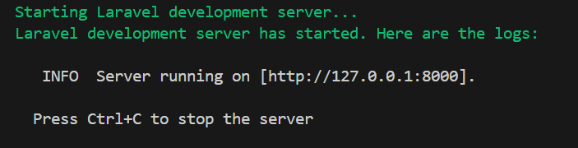

Figure 1: Getting started with the default URL

1. SAI Details
   * Once the URLs are entered in the browser, the following window will appear for the initial setup settings: the form for entering SAI details.

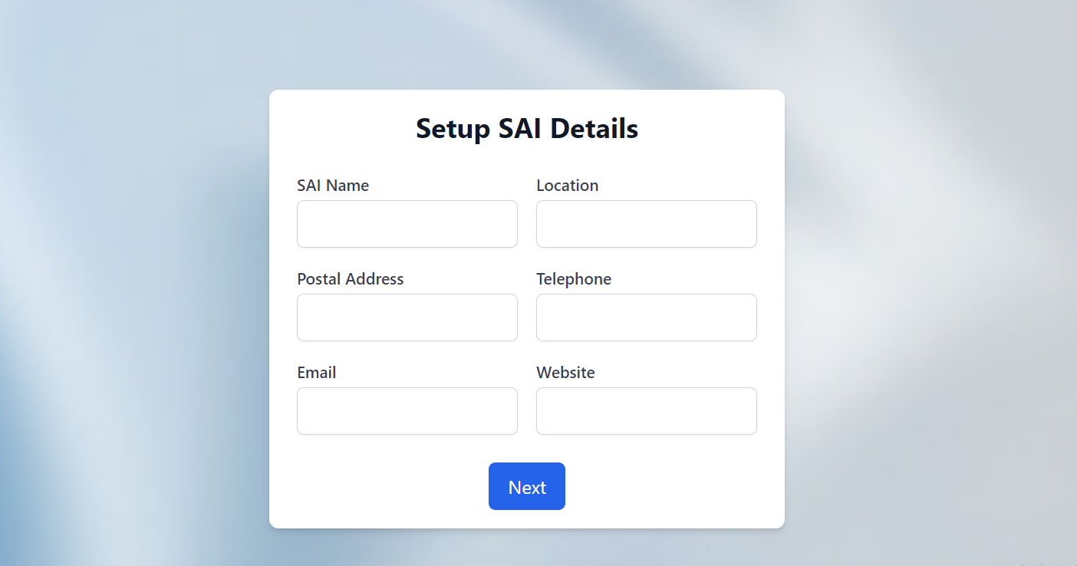

Figure 2: SAI Details Setup

1. Tool Name and Logo Settings
   * The next window will prompt you to enter a name and upload the logo that will be used by the tracking tool.

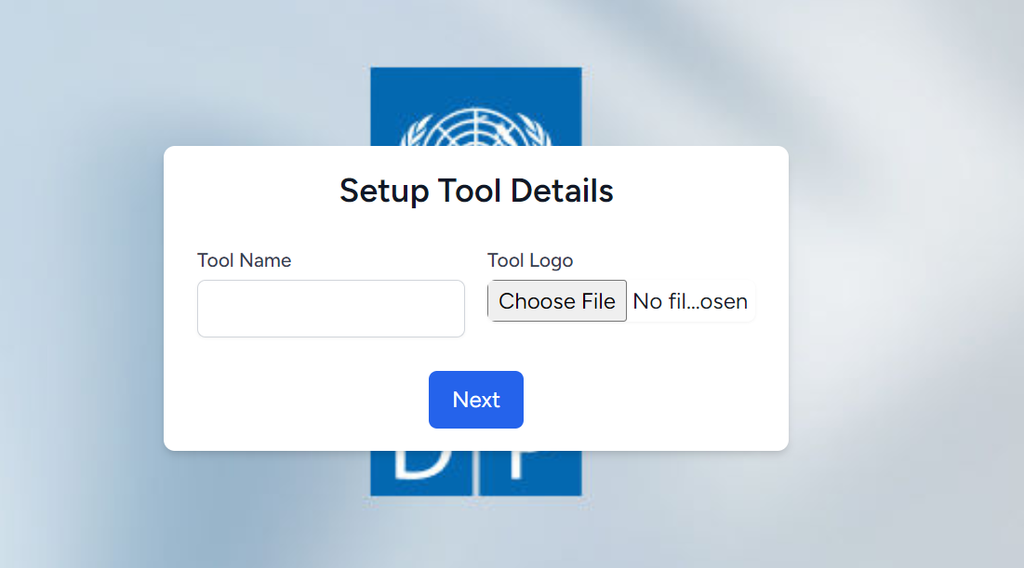

Figure 3: Tool Name and Logo Setup

1. Admin Setup

* Finally, set up the admin details, including the name, email, and password.

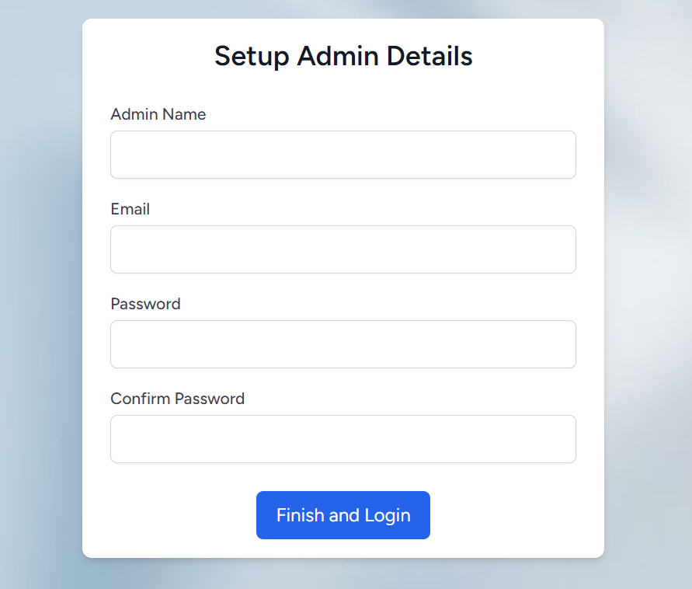

Figure 4: Admin Setup Task

* The next window will display the login page for the admin account created.

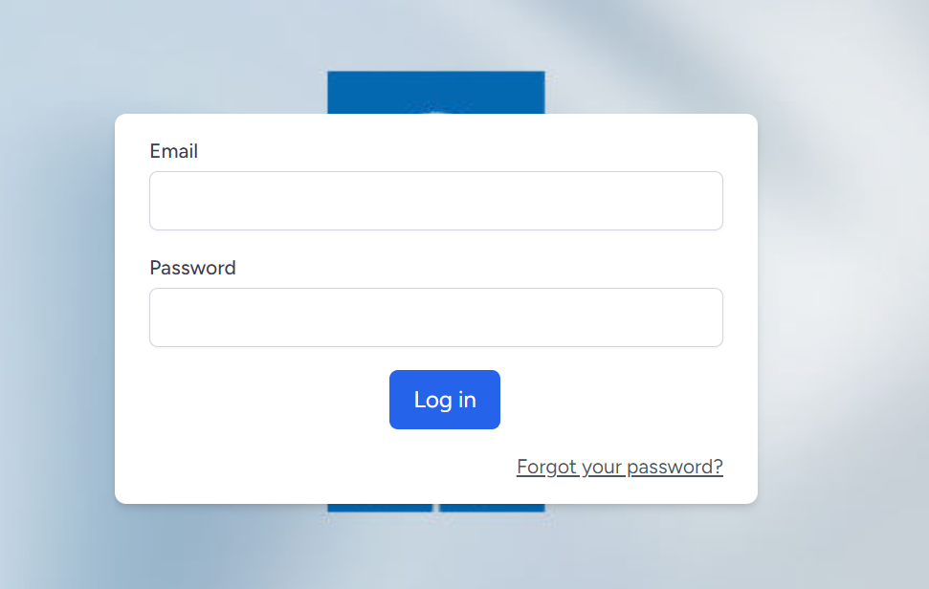

Figure 5: Login Page

* Then, the password window will be prompted to change the password

## Must know web routes on the browser after the final setup details:

1. <http://localhost:8000/> **//for public dashboard**
2. <http://localhost:8000/>login **//for admin login page**

.

# Client & Stakeholder Module

## Stakeholder Settings

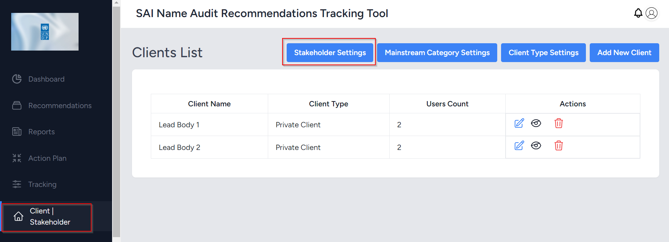

Figure 6: Setting up the stakeholders

Figure 7: Actions to add, edit, view, or remove stakeholders

**Use**: To add stakeholder and their details

**Steps**:

1. In the Client | Stakeholder settings section, click on **Stakeholder Settings**
2. In the next window, the user can add a new stakeholder using the button **Add New Stakeholder**
3. The user can also perform actions like deleting and editing the details of the stakeholder
4. Users can also view details of the stakeholders and users the stakeholders have.

## Mainstream Category Settings

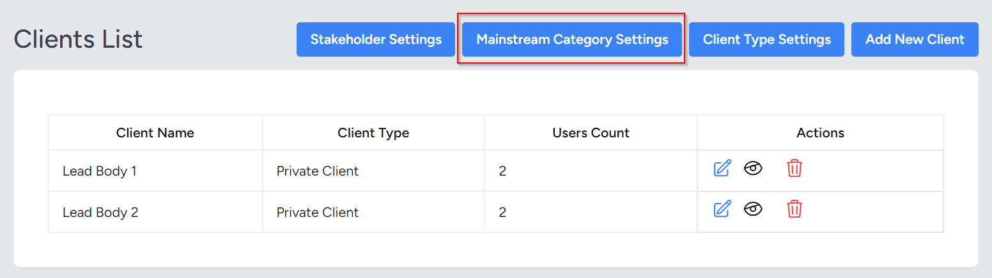

Figure 8: Mainstream category settings process start

Figure 9: Add, edit, and delete the category's actions

**Use**: To add, update, and remove mainstream categories

**Steps**:

1. In the Client | Stakeholder section, click **Mainstream Category Settings**
2. In the next window, perform actions like adding a new category, or editing or deleting the categories.
3. Complete each action by using the **Save**, **Update**, or **Delete** buttons as appropriate

## Client Type Settings

Figure 10: Client type settings process start

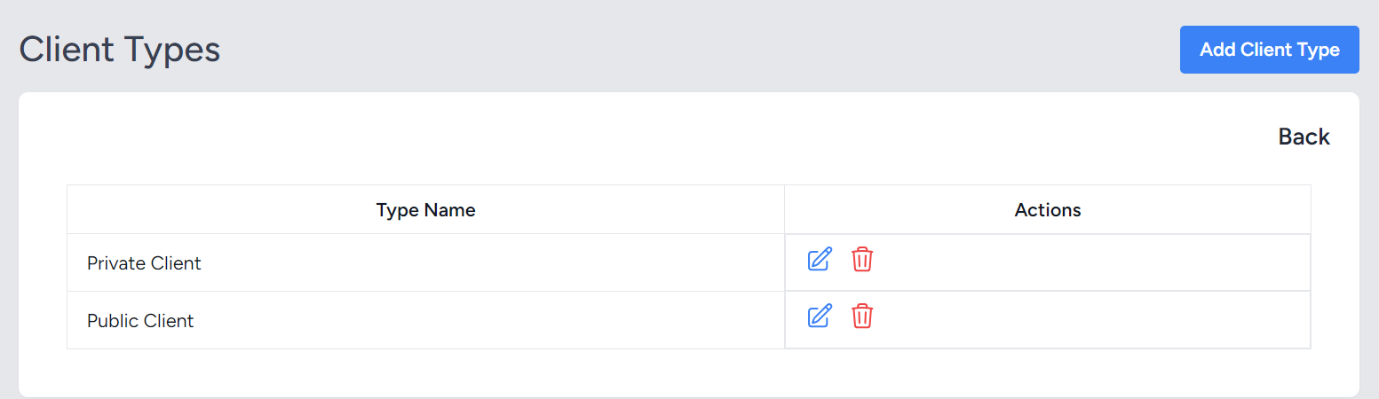

Figure 11: Add, edit, and delete client type

**Use**: To add, update, or remove types of clients that SAI audits

**Steps**:

1. In the **Client|Stakeholde**r section, click the **Client Type Settings** button
2. In the next window, use the options to add new client types, or edit or delete existing types
3. Complete each action using the **Save**, **Update**, or **Delete** buttons as appropriate

**Note**: The Private or Public Client could be a Ministry, a Department, a Statutory Corporation, etc. depending on the type of clients a SAI audits.

## Client Settings

Figure 12: Client setup and view process.

Figure 13: Adding new client

**Use**: Adding new client or lead body that has been audited.

**Steps**:

1. In the **Client|Stakeholder** section, click the **Add New Client** button
2. In the next window, enter the client’s name and select the client type
3. Click save to complete the process
4. The newly added clients will appear on the **Client|Stakeholder** main page, where you can edit, view, or delete them

# Users Module

## Add New Users

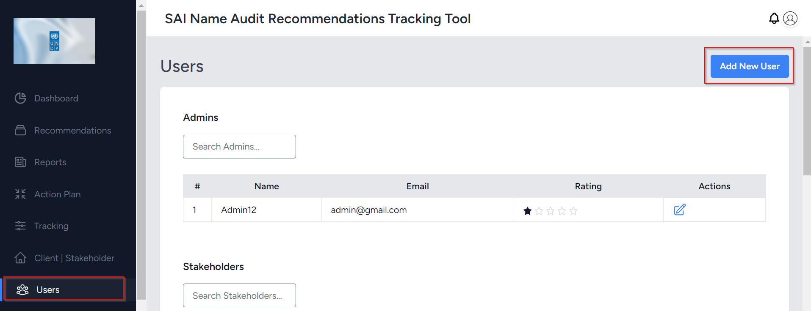

Figure 14: Adding a new user process start

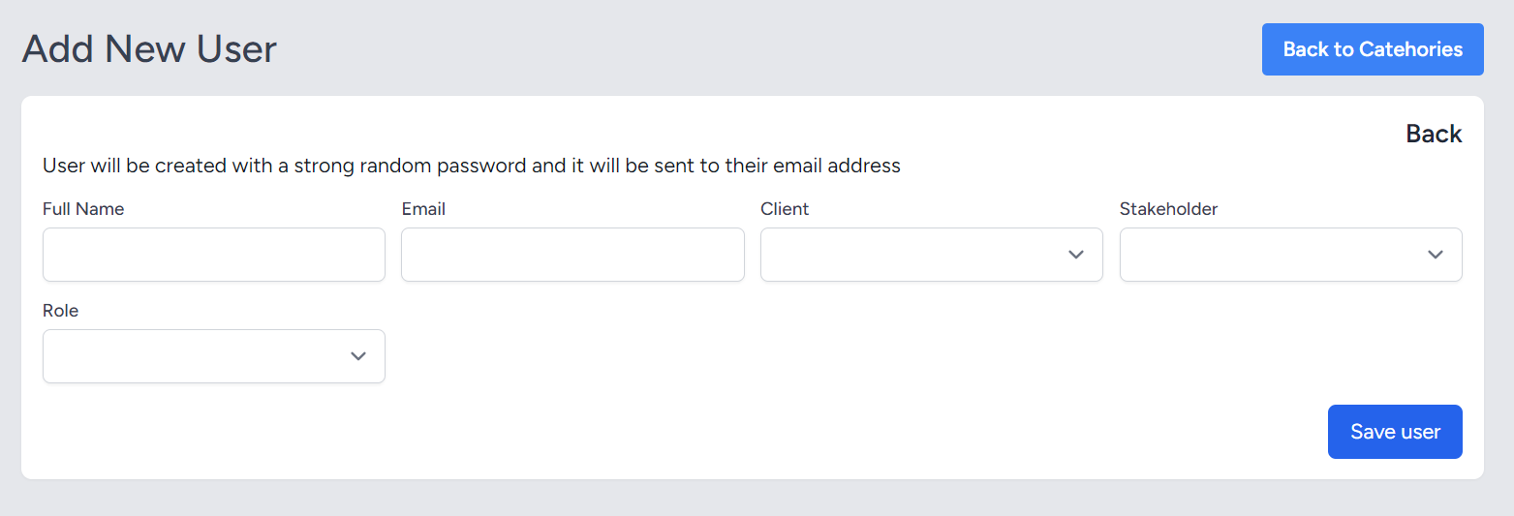

Figure 15: Form to fill in user details

## View Admins List

Figure 16: List of Admins and the ratings

## View Stakeholders and its Users

Figure 17: List of stakeholders created from Stakeholder settings

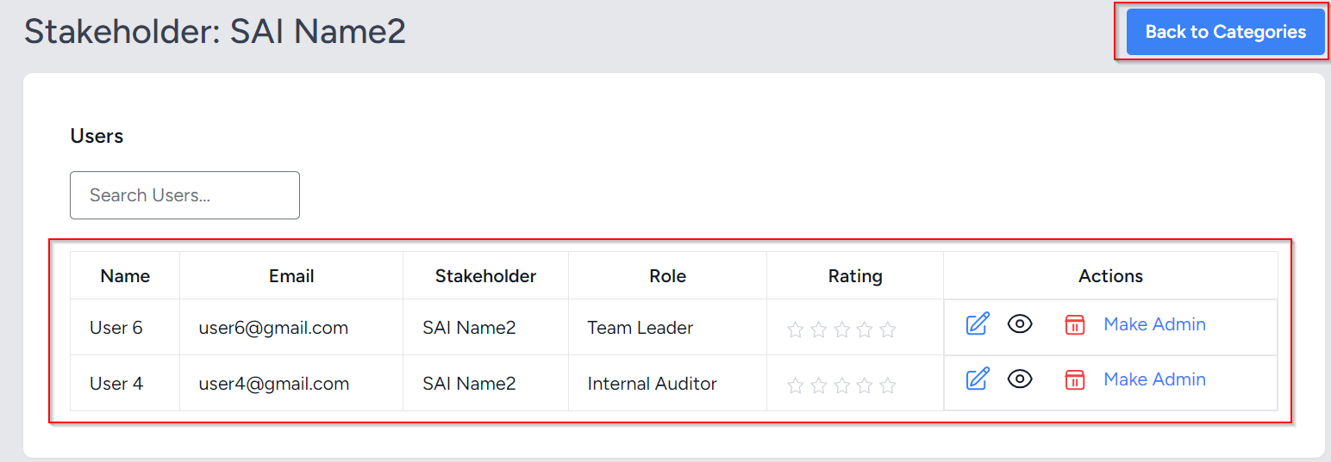

Figure 18: List of stakeholder users

## View Client and Its Users

Figure 19: List of clients and ratings

Figure 20: List of Client users. The Client selected was Lead Body 2

## Change User Roles

Figure 21: Changing user role to admin

**Use**: To create, update, view, remove, and change the roles of the users

**Steps**:

1. Click on the **Users** tab in the menu
2. Click on the **Add New User** button
3. Fill in the user's details, specify whether the user is from a stakeholder or client (lead body), and assign a role.
4. For new users, the default password is Password@12
5. On the main **Users** page, users are categorized into Admins, Stakeholders, and Clients
6. To view stakeholder users, click the stakeholder name and the users will be shown in the next window
7. While viewing stakeholder or client users, you can edit or view their details, including roles and permissions.
8. Users from clients and stakeholders can be promoted to Admins by using the "Make Admin" action available in the relevant view.
9. Confirm any deletions or changes to admin roles to complete the process

# Roles Module

## Add New Role, Remove and Edit Roles

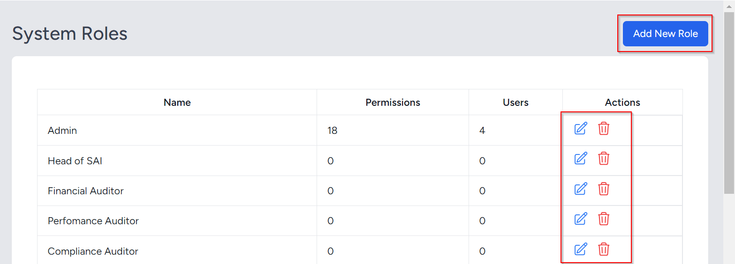

Figure 22: Role creation, edit and remove actions

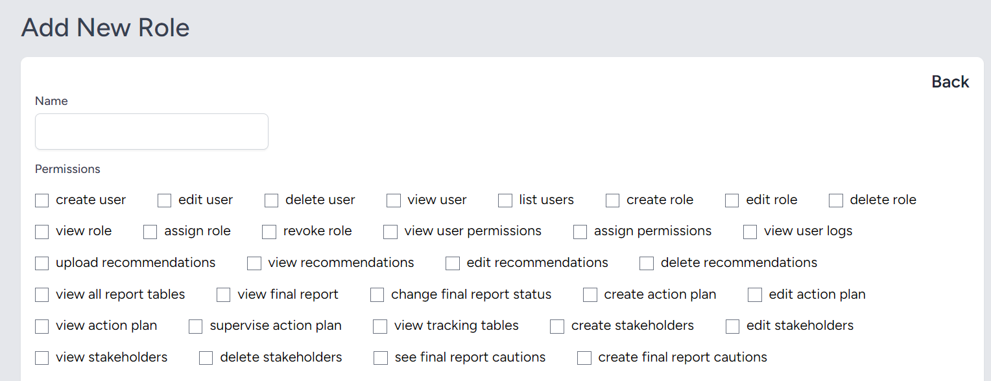

Figure 23: Add new role name and assign permissions

## Assign Permissions to Roles

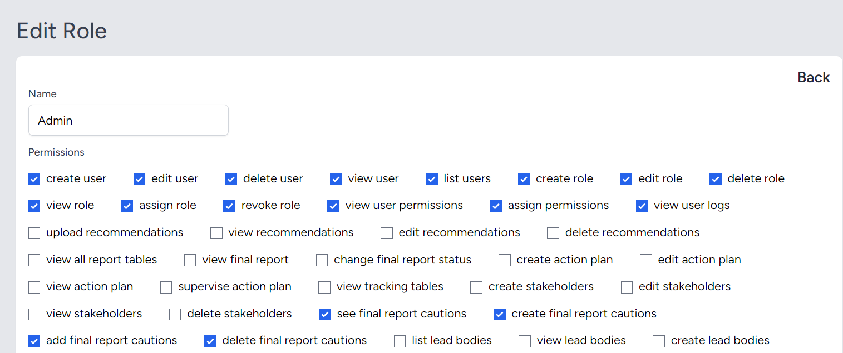

Figure 24: Assigning Permissions to a Role

**Use**: To add new roles, update the roles, and assign permissions to the roles

**Steps**:

1. In the **Roles** section, click the **Add New Role** button
2. Fill in the name of the role required and the assign permissions for the role
3. To edit or delete the role, the actions are available in the table just under the **Roles** tab section

# FAQS

1. **What are the system requirements to install the Audit Recommendation Tracking Tool?**

* The required software for installation includes **XAMPP** (which includes Apache, MySQL, PHP, and phpMyAdmin) and **Composer** (for managing PHP dependencies).
* After installing XAMPP and Composer, you can proceed to download, extract, and set up the Laravel project for the tool.

1. **How do I set up the admin user during the initial tool setup?**

* After entering the SAI details and configuring the tool’s name and logo, you will be prompted to set up the admin details.
* This includes entering the admin’s name, email, and password. The admin can then log in to the system to complete the setup.

1. **Can I modify or delete stakeholders, clients, or their roles within the tool?**

* Yes, you can add, edit, or delete stakeholders, clients, and their roles. In the Client & Stakeholder module, you can configure stakeholder settings, add new clients, and assign client types.
* Additionally, users can modify roles and permissions in the Roles module to manage user access.

1. **How do I add new users to the system, and what default password is assigned to them?**

* To add a new user, go to the Users module, click on **Add New User**, and fill in the necessary details, including the user's role (Admin, Stakeholder, or Client). For new users, the default password is **Password@12**, which can be changed later.

1. **How can I assign roles and permissions to users in the system?**

* In the Roles module, you can add new roles by clicking **Add New Role**, entering a role name, and assigning the appropriate permissions.
* You can also edit or remove roles by selecting the relevant options under the **Roles** tab. To update user roles, navigate to the Users module and change their role accordingly.

1. **What are the steps to migrate the database after setting up the tool?**

* After extracting the Laravel project, run the following command in your terminal or command prompt to migrate the schema and seed the database:  
  php artisan start_tool
* This command will also start the Laravel development server. If you need to restart the server, use:  
  php artisan serve.

1. **What are the steps to migrate the database after setting up the tool?**

* After extracting the Laravel project, run the following command in your terminal or command prompt to migrate the schema and seed the database:  
  ***php artisan start_tool***
* This command will also start the Laravel development server. If you need to restart the server, use:  
  ***php artisan serve***

1. **How do I access the public dashboard or login as an admin?**

* After completing the setup, you can access the **public dashboard** at http://localhost:8000/. For **admin login**, navigate to http://localhost:8000/login where you can enter your admin credentials.

1. **How can I manage client types within the tool?**

* In the **Client & Stakeholder module**, you can manage client types by going to **Client Type Settings**. Here, you can add new client types, edit existing ones, or remove types, and assign these to clients accordingly.

1. **Can I view and manage users from both stakeholders and clients?**

* Yes, in the **Users module**, you can view and manage users from both stakeholders and clients. Users are categorized into **Admins**, **Stakeholders**, and **Clients**. You can add new users, view existing users, change roles, or even promote stakeholders and clients to admin roles.

1. **What happens if I forget to set up the tool logo or name during the initial setup?**

* If the tool's name and logo are not configured during the initial setup, you can update these settings later through the **Tool Setup Settings** section. The logo and name can be modified at any time by accessing the relevant fields from the admin interface.

# Troubleshooting Guide

1. **Error: "Incorrect Date Format When Uploading CSV"**

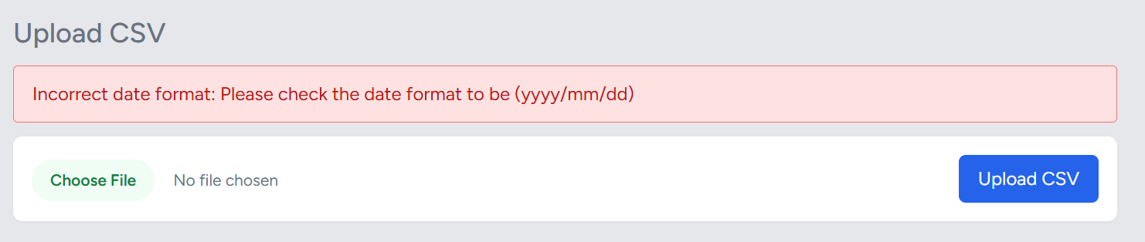

Figure 25: Incorrect Date Error

* **Cause**: This error occurs when the date in the CSV file is not in the correct format, which is expected to be **(yyyy/mm/dd)**.
* **Solution**:
  1. Ensure that all date columns in the CSV file are formatted correctly. The required format is **yyyy/mm/dd**. For example:
     + Correct date format: 2024/12/02
     + Incorrect date format: 12-02-2024, 02/12/2024, or 12/02/2024
  2. If the error message appears, verify that the dates in the CSV are corrected before uploading.
  3. The error message displayed will be:  
     **"Incorrect date format: Please check the date format to be (yyyy/mm/dd)"**
  4. Open the CSV file in a text editor or spreadsheet application (like Excel) and ensure all date fields follow the **yyyy/mm/dd** format. If necessary, use a date formatting function to correct the format before re-uploading.

1. **Error: "Invalid Array # in CSV Upload" or CSV Sample date.**

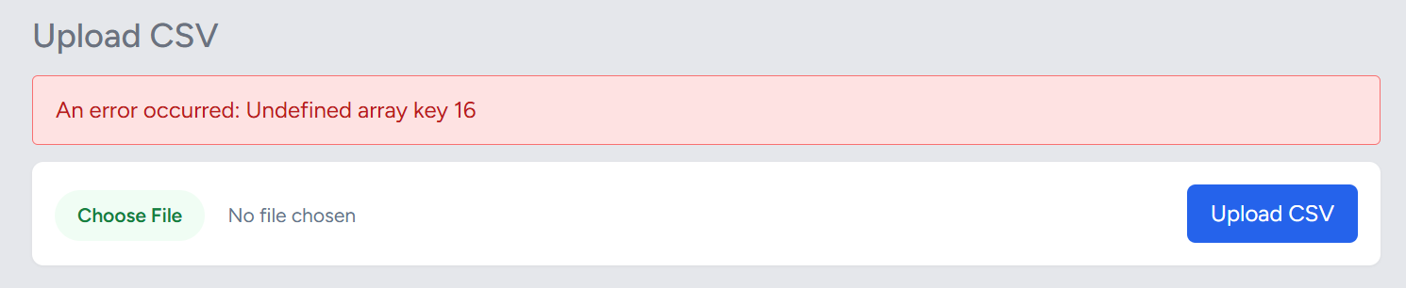

Figure 26: Array Error

* **Cause**: This error occurs when the CSV file either does not contain the required fields or has missing/incorrect data in any of the rows. Issues often arise in columns that are part of the array, particularly when invalid characters (such as "~", ",", or others) are introduced, or when there are formatting issues. These invalid characters may cause injection errors, corrupt the data, or prevent the tool from processing the CSV file correctly.
* **Solution**:
  1. Ensure that all the necessary fields in the CSV file are populated with valid data. The tool expects specific columns to contain specific types of data, such as dates, numeric values, and text. If any required field is missing, improperly formatted, or contains invalid characters (e.g., "~", ",", or other special symbols), this error may occur.
  2. Review the **sample CSV file** provided in the manual or tool interface. It will list the exact fields required for each row of data (e.g., date, recommendation ID, stakeholder name, etc.).
  3. Check that all columns are correctly populated and contain no blank or invalid values. Pay close attention to special characters or symbols like "~", ",", or other non-alphanumeric characters that may interfere with the system's parsing of the data. These characters can trigger injection errors or cause the file to be rejected.
  4. If the error occurs, the message will indicate:  
     **"Invalid array #: Please ensure all required fields have proper data."**
  5. Open the CSV file and ensure all fields required by the system are filled and formatted correctly (e.g., dates in the proper format, numeric fields as numbers, text fields with valid data).

1. **Error: "Internet Connection Required for Supervising Action Plans, Making Notes, Cautioning Recommendations, or Auto-Generated Reminders"**

* **Cause**: This error occurs when performing tasks such as supervising action plans, making notes on recommendations, cautioning not fully implemented recommendations, or generating auto-reminders for recommendations not fully implemented within the last 30 days. These actions require an active internet connection as they involve synchronizing data, and sending notifications
* **Solution**:
  1. **Ensure Active Internet**: Ensure that your device has a **stable internet connection**. These features rely on internet access to send and receive data, such as:
     + Supervising or updating action plans.
     + Adding notes or cautioning recommendations that are not fully implemented.
     + Sending **auto-generated reminders** for recommendations that have not been fully implemented within the last 30 days.
  2. **Network Configuration**: If you are using a **corporate or restricted network**, verify that your firewall or proxy settings allow the necessary communication for the tool to function correctly.
  3. **Stable Connection**: If you are experiencing intermittent connection issues, ensure the internet is stable. Try reconnecting to the network or switching to a different network (e.g., from Wi-Fi to a wired connection) to improve stability.
  4. **Retry After Connection**: If the issue occurs after a temporary loss of connection, try reloading the page or performing the action again once the internet connection is restored.

1. **Changing logo, tool name and the stakeholder details due to wrong data during initial Tool Setup.**

* In the Settings module, the administrator can change the logo and the name of the tool
* The name of the tool should only contain few words, such as SAI Name, as show in the picture below.

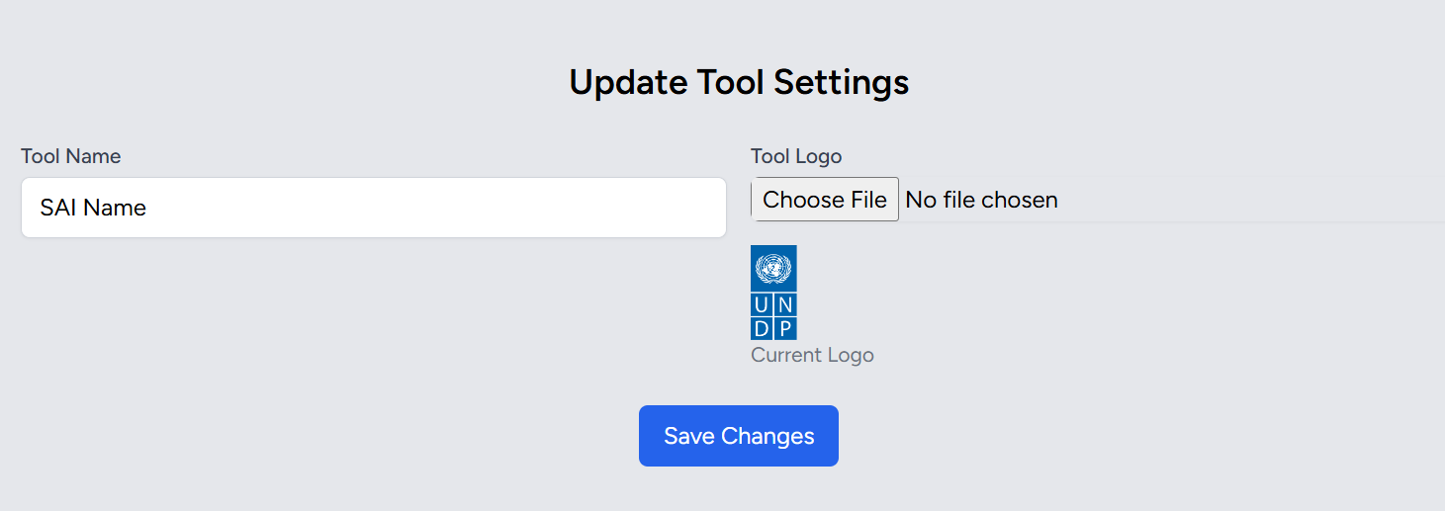

Figure 27: Tool Name and the logo update

* To update stakeholder settings, navigate to a Client and Stakeholder module, click on the Stakeholder Settings button and there is a list of stakeholders in the table.
* Change using the edit icon in the actions, shown below and t

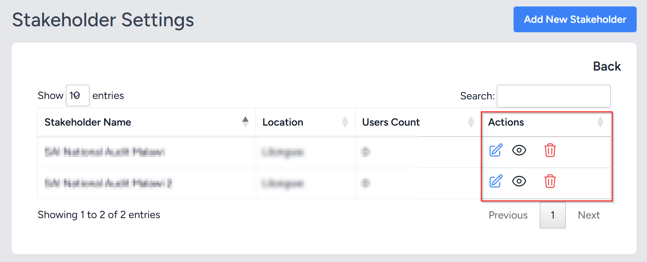

Figure 28: Updating the stakeholder settings

1. **Error: "Strange or Unrecognized Error"**

* **Cause**: This error occurs when the system displays an unexpected behavior or an error message that is not recognized or cannot be easily explained.
* **Solution**:
  1. **Clear Cache**: If the issue is unexpected or strange, try clearing your browser cache and reloading the page to rule out any caching problems.
  2. **Reproduce the Error**: If possible, note the steps that lead to the error so that it can be accurately reported.
  3. **Contact the Administrator**: If the error persists and the message remains unclear, please contact the **administrator** or **development team** for assistance. Provide as much detail as possible, including:
     + A description of the error or strange behavior.
     + Any steps you took that triggered the error.
     + Screenshots or logs (if available).
  4. The **administrator** will investigate the issue and work on resolving it.